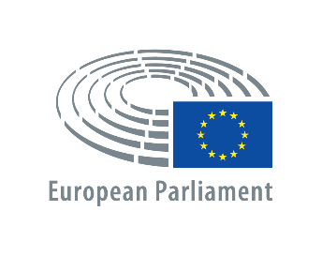
Public Hearing
”The remaining 12 years: EU action towards achieving the 2030 Agenda for Sustainable Development”

Thursday 7 February 2019, 09h00 - 11h30
Altiero Spinelli (ASP) building - room 5G3

DRAFT PROGRAMME
09:00 Linda McAVAN, Chair of the Committee on Development
Adina-Ioana VĂLEAN, Chair of the Committee on the Environment, Public Health and Food Safety
09:10 Keynote speech, presenting the Commission Reflection Paper 'Towards a Sustainable Europe by 2030'
Frans TIMMERMANS,
First Vice-President of the European Commission
09:25 Q&A session
09:55 Ingeborg NIESTROY, Managing Director, Public Strategy for Sustainable Development
Elisabeth HEGE, Research Fellow, Institute for Sustainable Development and International Relations (IDDRI)
Presentation of the study ‘Europe's approach to implementing the Sustainable Development Goals: Good practices and the way forward’
10:05 Jean-Pascal VAN YPERSELE, Former IPCC Vice-Chair (Intergovernmental Panel on Climate Change) and current Chair of the Energy and Climate Working Group Federal Council for Sustainable Development, Belgium
Eeva FURMAN, Chair of Finland´s Expert Panel for Sustainable Development, Director of the Environmental Policy Centre, Finnish Environment Institute (SYKE)
Presentation of preparations of the UN ‘The Global Sustainable Development Report 2019’
10:20 Q&A session
10:50 Keynote speech:
‘A European Strategy to Achieve the Sustainable Development Goals’
Jeffrey Sachs, Chair of the Sustainable Development Solutions Network and Director of the Center for Sustainable Development at Columbia University
11:05 Q&A session
11:30 Conclusion

