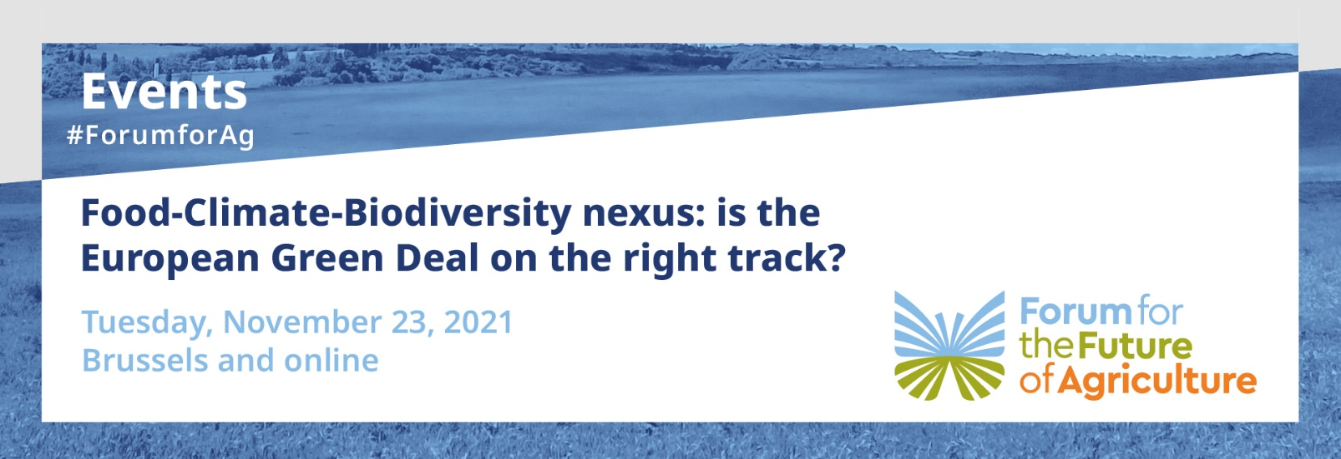

 | Stanhope Hotel Brussels, Balmoral I-II room and online
17:20 (CET) | Open the livestream link for online attendees and move people into the conference room
17:30 – 17:35 (CET) | Introductory remarks by  - Moderator Rose O’Donovan, Editor-in-Chief AGRA FACTS
17:35 –17:50 (CET) | Opening address: Key lessons from the first 18 months of the Farm to Fork Strategy  - Professor Erik Mathijs, KU Leuven (15’)
17:50 – 18:35 (CET) | Panel Discussion
17:50-18:20  (CET) | - Tassos Haniotis, Director & Acting Deputy Director-General, DG AGRI, European Commission (7’)  - Sébastien Treyer, Director, IDDRI- Institute for Sustainable Development  & International Relations (7’)  - Nathalie Chaze, Director Food sustainability & International relations,  DG SANTE, European Commission (7’)  - Dik Kruijthoff, Managing Partner at Novafarm in the Netherlands (7’) (joining remotely)  Moderator: Rose O’ Donovan, Editor-in-Chief AGRA FACTS
18:20-18:35 | - Panel discussion (20’)
18:35-18:50  (CET) | Open Q&A session with audience in the room and online (15’)
18:50– 19:00 (CET) | Closing Remarks
 | - Dr. Peter Strohschneider, Chairman, German Commission on the Future of Agriculture (10’) (joining online)
19:00  (CET) | - Closing word by Rose O’Donovan
19:00 – 21:00 (CET) | Cocktail followed by a seated dinner  Stanhope Hotel Brussels, Balmoral III room

In partnership with: | 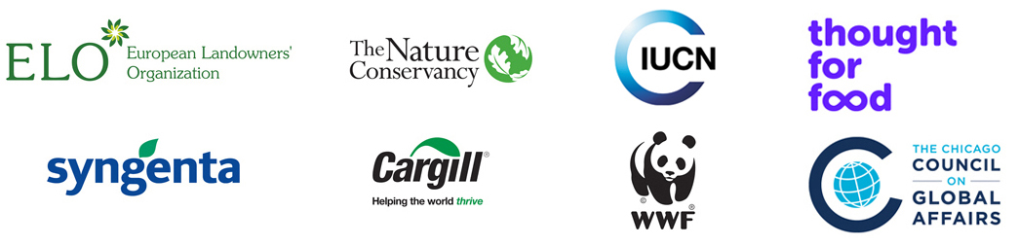

Concept note:

Two years ago, the Commission established its priorities, with the European Green Deal taking center stage in political debates in Brussels & the EU capitals. With a strong & widely supported vision for Europe to become the world’s first climate-neutral continent by 2050, the EU Climate Law has already entered into force and the ‘Fit for 55’climate legislative package is well underway, with significant implications for the land use sector.
The European Green Deal was translated to the policy areas of food & biodiversity with the publication in May 2020 of the Farm to Fork Strategy & the Biodiversity Strategy to 2030. These Strategies have been generally welcomes, including by the European Parliament &Member States, who have shown their support for using a food systems approach to tackle the food-climate-biodiversity nexus in an integrated way. This same approach has been at the core of the recent UN Food Systems Summit held in New York in September 2021.
Nevertheless, the Farm to Fork & Biodiversity Strategies also set a number of ambitious non-binding targets for EU agriculture, aiming to reduce the use of agrochemicals, boost organic agriculture & increase biodiversity-rich landscape features on farms. These targets, which give an orientation to possible changes that should or could occur in order to shift the European food systems, have not been well received by the majority of the agricultural players, who do not see how such targets could be reasonably achieved.
The publication in recent months of a series of studies assessing the implications of these targets for EU’s agriculture & agri-food trade markets has further strained the political debate. Stakeholders are taking more entrenched positions than before, rather than bridging & identifying the right tools to make progress. But progress in what direction? The overstretched use of the term “sustainability” & the absence of a “net-zero concept” that would be applicable to food systems is also making the task more difficult.
Eighteen months after the Farm to Fork & Biodiversity Strategies were adopted by the European Commission, & with very important policy initiatives in these areas in the pipeline, it is time to take stock and look into the future. In the best spirit of this Forum, where agriculture & environment meet for an open dialogue, we would like to hold a conversation on how the food-climate-biodiversity nexus can be best approached in EU policy-making.
Can we agree on a shared vision for sustainable food systems? What are the criteria & indicators that make up that vision? What policy tools & instruments do we need to shift from current systems to long-term sustainability criteria? How can we create food systems feedback loops that connect better income for food producers with biodiversity protection or climate protection? What elements could allow this unavoidable just transition, where each actor of the food chain acknowledge who the transition is for & who could contribute to a collective effort?

